Item No. |  | photo |  |  |  |  | Цены указаны по курсу 37р- 1$
 |  |  |  | Material:0.45/0.55PVC |  | Tarpaulin
IC0001 |  |  |  | Size:4mLx4mWx3.5mH |  |  | 45000
 |  |  |  | Blower:1pc，950W
 |  |  |  | Material:0.45/0.55PVC |  | Tarpaulin
IC0002 |  |  |  | Size:4.5mLx4.5mWx3.5mH |  |  | 56000
 |  |  |  | Blower:1pc，950W
 |  |  |  | Material:0.45/0.55PVC |  | Tarpaulin
IC0003 |  |  |  | Size:4.5mLx4.5mWx3.5mH |  |  | 56000
 |  |  |  | Blower:1pc，950W
 |  |  |  | Material:0.45/0.55PVC |  | Tarpaulin
IC0004 |  |  |  | Size:3mLx5mWx2.4mH
 |  |  |  | Blower:1pc，950W
 |  |  |  | Material:0.45/0.55PVC |  | Tarpaulin
IC0005 |  |  |  | Size:3mLx5mWx2.4mH |  |  | 43000
 |  |  |  | Blower:1pc，950W
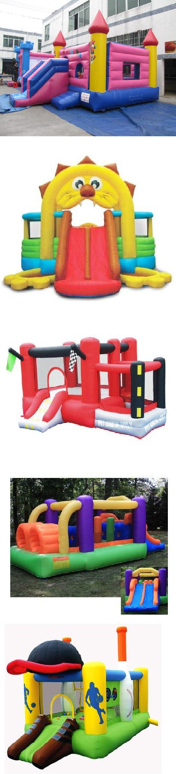

1/39

 |  | Material:0.45/0.55PVC | Tarpaulin
IC0006 |  | Size:5mLx5mWx3.5mH |  | 73500
 |  | Blower:1pc，950W
 |  | Material:0.45/0.55PVC | Tarpaulin
IC0007 |  | Size:3mLx4mWx3.5mH |  | 35000
 |  | Blower:1pc，950W
 |  | Material:0.45/0.55PVC | Tarpaulin
IC0008 |  | Size:3mLx5mWx3.5mH
 |  | Blower:1pc，950W
 |  | Material:0.45/0.55PVC | Tarpaulin
IC0009 |  | Size:4mLx5mWx3.5mH |  | 56000
 |  | Blower:1pc，950W
 |  | Material:0.45/0.55PVC | Tarpaulin
IC0010 |  | Size:3mLx5mWx3.5mH |  | 43000
 |  | Blower:1pc，950W
 |  | Material:0.45/0.55PVC | Tarpaulin
IC0011 |  | Size:4mLx5mWx3.5mH |  | 53000
 |  | Blower:1pc，950W
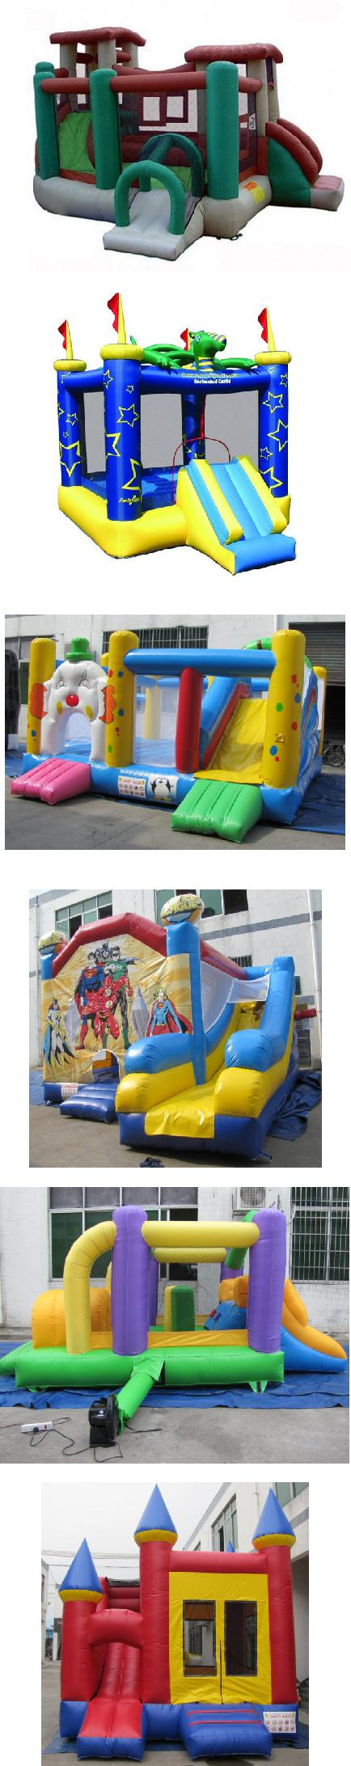

2/39

 |  | Material:0.45/0.55PVC | Tarpaulin
IC0012 |  | Size:3mLx6mWx3.5mH |  | 50000
 |  | Blower:1pc，1100W
 |  | Material:0.45/0.55PVC | Tarpaulin
IC0013 |  | Size:6mLx9mWx3.5mH |  | 140000
 |  | Blower:1pc，1500W
 |  | Material:0.45/0.55PVC | Tarpaulin
IC0014 |  | Size:4mLx7mWx3.5mH |  | 77000
 |  | Blower:1pc，1100W
 |  | Material:0.45/0.55PVC | Tarpaulin
IC0015 |  | Size:3mLx5mWx3.5mH |  | 43000
 |  | Blower:1pc，950W
 |  | Material:0.45/0.55PVC | Tarpaulin
IC0016 |  | Size:5mLx5mWx3.5mH |  | 64000
 |  | Blower:1pc，1100W
 |  | Material:0.45/0.55PVC | Tarpaulin
IC0017 |  | Size:5mLx5mWx3.5mH |  | 69000
 |  | Blower:1pc，1100W
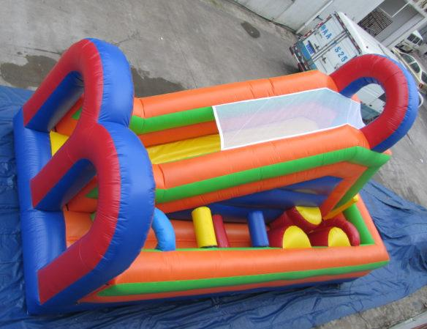
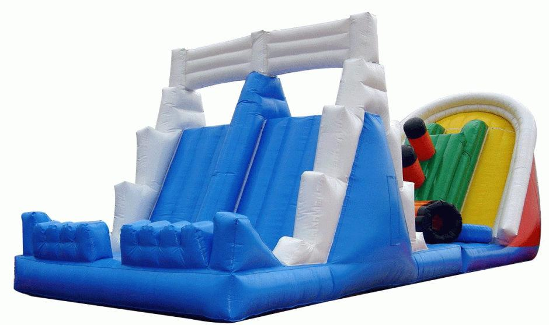
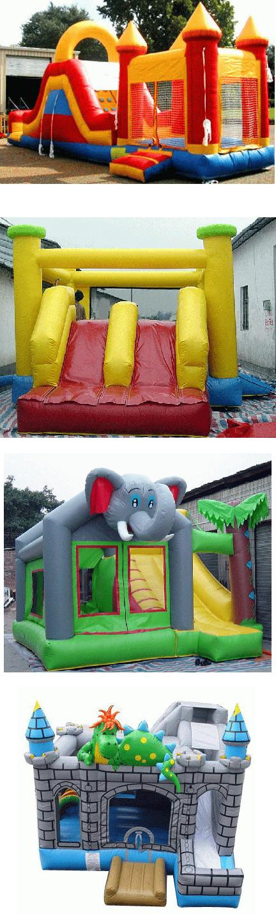

3/39

 |  | Material:0.45/0.55PVC | Tarpaulin
IC0018 |  | Size:5mLx5mWx3.5mH |  | 75000
 |  | Blower:1pc，1100W
 |  | Material:0.45/0.55PVC | Tarpaulin
IC0019 |  | Size:5mLx5mWx3.5mH |  | 70000
 |  | Blower:1pc，1100W
 |  | Material:0.45/0.55PVC | Tarpaulin
IC0020 |  | Size:3.5mLx5mWx3.5mH |  | 49000
 |  | Blower:1pc，950W
 |  | Material:0.45/0.55PVC | Tarpaulin
IC0021 |  | Size:4.5mLx4.5mWx3.5mH |  | 56000
 |  | Blower:1pc，950W
 |  | Material:0.45/0.55PVC | Tarpaulin
IC0022 |  | Size:4.5mLx4.5mWx3.5mH |  | 56000
 |  | Blower:1pc，950W
 |  | Material:0.45/0.55PVC | Tarpaulin
IC0023 |  | Size:4.5mLx4.5mWx3.5mH |  | 53000
 |  | Blower:1pc，950W
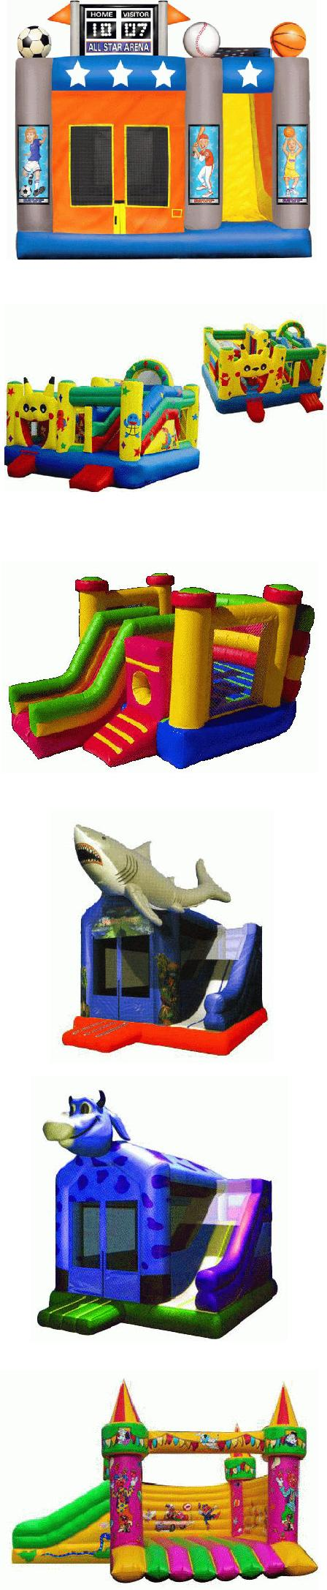

4/39

 |  | Material:0.45/0.55PVC | Tarpaulin
IC0024 |  | Size:4.5mLx4.5mWx3.5mH |  | 56000
 |  | Blower:1pc，950W
 |  | Material:0.45/0.55PVC | Tarpaulin
IC0025 |  | Size:3mLx6mWx3.5mH |  | 50000
 |  | Blower:1pc，1100W
 |  | Material:0.45/0.55PVC | Tarpaulin
IC0026 |  | Size:3mLx6mWx3.5mH |  | 50000
 |  | Blower:1pc，1100W
 |  | Material:0.45/0.55PVC | Tarpaulin
IC0027 |  | Size:5mLx5mWx3.5mH |  | 60000
 |  | Blower:1pc，1100W
 |  | Material:0.45/0.55PVC | Tarpaulin
IC0028 |  | Size:3mLx6mWx3.5mH |  | 45500
 |  | Blower:1pc，1100W
 |  | Material:0.45/0.55PVC | Tarpaulin
IC0029 |  | Size:4mLx5mWx3.5mH |  | 53000
 |  | Blower:1pc，1100W
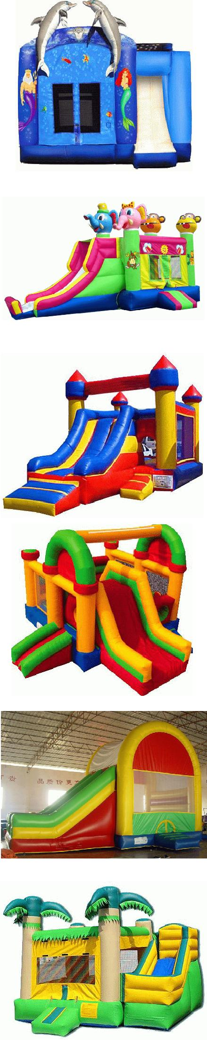

5/39

 |  | Material:0.45/0.55PVC | Tarpaulin
IC0030 |  | Size:5mLx6mWx3.5mH |  | 70000
 |  | Blower:1pc，1500W
 |  | Material:0.45/0.55PVC | Tarpaulin
IC0031 |  | Size:4mLx4mWx3mH |  | 45000
 |  | Blower:1pc，950W
 |  | Material:0.45/0.55PVC | Tarpaulin
IC0032 |  | Size:4mLx5mWx3mH |  | 55000
 |  | Blower:1pc，950W
 |  | Material:0.45/0.55PVC | Tarpaulin
IC0033 |  | Size:4mLx5mWx3mH |  | 55000
 |  | Blower:1pc，950W
 |  | Material:0.45/0.55PVC | Tarpaulin
IC0034 |  | Size:4mLx5mWx3mH |  | 53000
 |  | Blower:1pc，950W
 |  | Material:0.45/0.55PVC | Tarpaulin
IC0035 |  | Size:4mLx5mWx3mH |  | 53000
 |  | Blower:1pc，950W
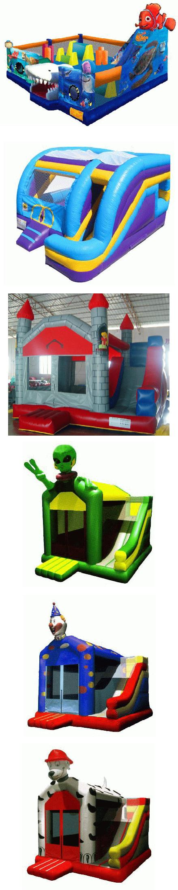

6/39

 |  | Material:0.45/0.55PVC | Tarpaulin
IC0036 |  | Size:4mLx5mWx3mH |  | 53000
 |  | Blower:1pc，950W
 |  | Material:0.45/0.55PVC | Tarpaulin
IC0037 |  | Size:5mLx8mWx3.5mH |  | 105000
 |  | Blower:1pc，1500W
 |  | Material:0.45/0.55PVC | Tarpaulin
IC0038 |  | Size:4mLx6mWx3mH |  | 65000
 |  | Blower:1pc，1100W
 |  | Material:0.45/0.55PVC | Tarpaulin
IC0039 |  | Size:4mLx5mWx3.5mH |  | 53000
 |  | Blower:1pc，950W
 |  | Material:0.45/0.55PVC | Tarpaulin
IC0040 |  | Size:4mLx5mWx3.5mH |  | 53000
 |  | Blower:1pc，950W
 |  | Material:0.45/0.55PVC | Tarpaulin
IC0041 |  | Size:4mLx5mWx3.5mH |  | 53000
 |  | Blower:1pc，950W
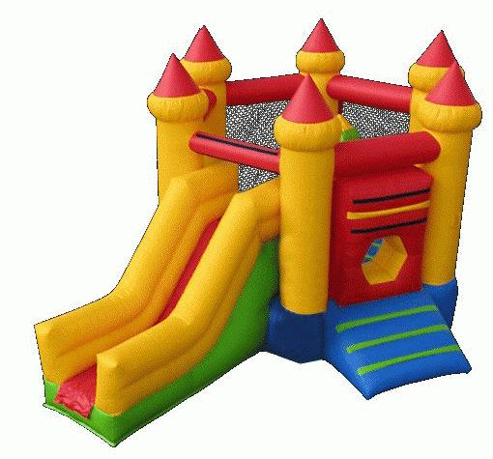
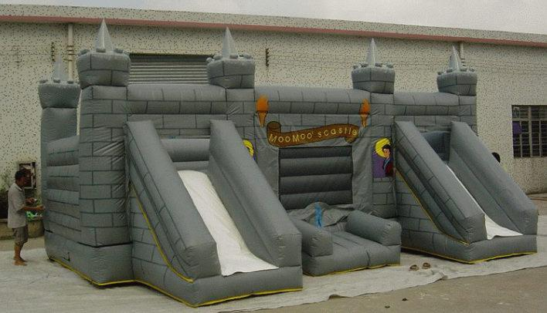
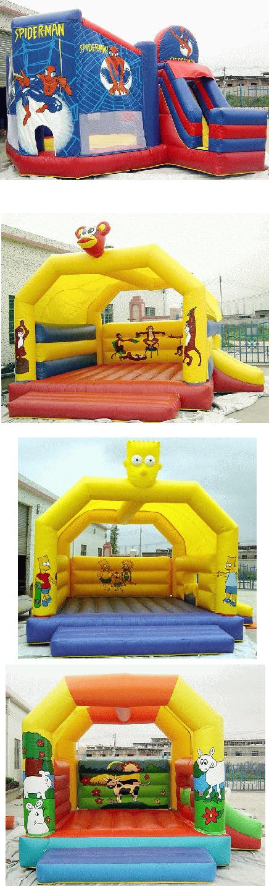

7/39

 |  | Material:0.45/0.55PVC | Tarpaulin
IC0042 |  | Size:4mLx5mWx3.5mH |  | 55000
 |  | Blower:1pc，950W
 |  | Material:0.45/0.55PVC | Tarpaulin
IC0043 |  | Size:4mLx10mWx4mH |  | 105000
 |  | Blower:1pc，1500W
 |  | Material:0.45/0.55PVC | Tarpaulin
IC0044 |  | Size:4mLx14mWx4.5mH |  | 150000
 |  | Blower:1pc，1500W
 |  | Material:0.45/0.55PVC | Tarpaulin
IC0045 |  | Size:5mLx8mWx3.5mH |  | 105000
 |  | Blower:1pc，1500W
 |  | Material:0.45/0.55PVC | Tarpaulin
IC0046 |  | Size:直径8m 高5m |  | 150000
 |  | Blower:1pc，1100W/2pcs
 |  | Material:0.45/0.55PVC | Tarpaulin
IC0047 |  | Size:8mLx10mWx5.5mH |  | 200000
 |  | Blower:1pc，1100W/2pcs
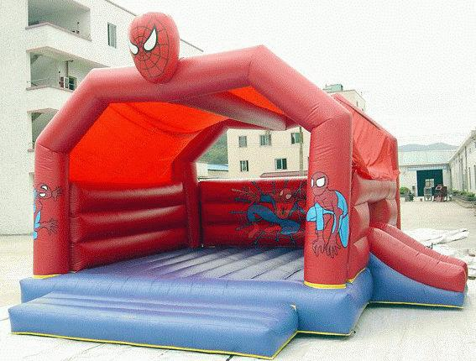
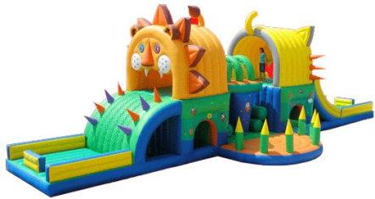
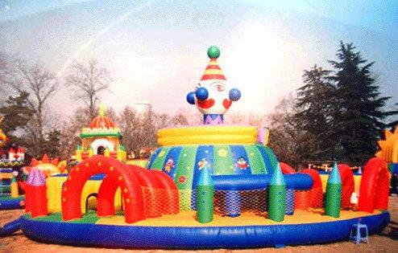

8/39

 |  | Material:0.45/0.55PVC | Tarpaulin
IC0048 |  | Size:6mLx10mWx5.5mH |  | 145000
 |  | Blower:1pc，1100W/2pcs
 |  | Material:0.45/0.55PVC | Tarpaulin
IC0049 |  | Size:6mLx10mWx5.5mH |  | 145000
 |  | Blower:1pc，1100W/2pcs
 |  | Material:0.45/0.55PVC | Tarpaulin
IC0050 |  | Size:6mLx8mWx5mH |  | 125000
 |  | Blower:1pc，1500W
 |  | Material:0.45/0.55PVC | Tarpaulin
IC0051 |  | Size:直径10m 高4.5m |  | 280000
 |  | Blower:1pc，1500W/2pcs
 |  | Material:0.45/0.55PVC | Tarpaulin
IC0052 |  | Size:4.5mLx15mWx6mH |  | 200000
 |  | Blower:1pc，1500W/2pcs
 |  | Material:0.45/0.55PVC | Tarpaulin
IC0053 |  | Size:3.5mLx7mWx4mH |  | 70000
 |  | Blower:1pc，1100W
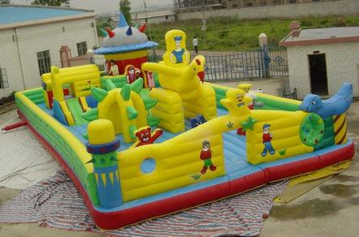
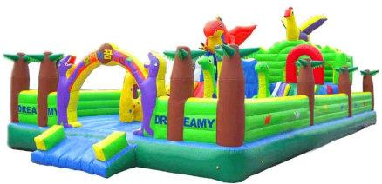
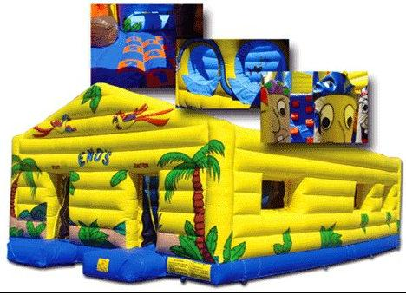
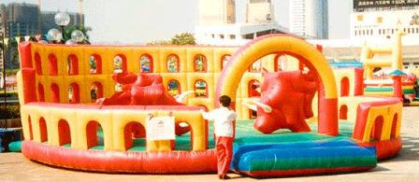
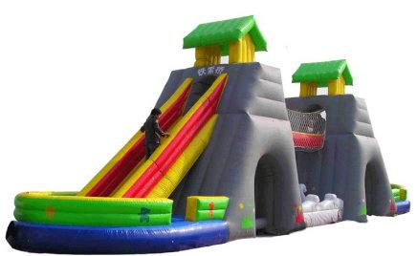

9/39

 |  | Material:0.45/0.55PVC | Tarpaulin
IC0054 |  | Size:5mLx5mWx2.4mH |  | 63000
 |  | Blower:1pc，1100W
 |  | Material:0.45/0.55PVC | Tarpaulin
IC0055 |  | Size:φ10m H:6m |  | 270000
 |  | Blower:1pc，1500W/2pcs
 |  | Material:0.45/0.55PVC | Tarpaulin
IC0056 |  | Size:3mLx8mWx3.5mH |  | 65000
 |  | Blower:1pc，1100W
 |  | Material:0.45/0.55PVC | Tarpaulin
IC0057 |  | Size:4mLx10mWx3.8mH |  | 105000
 |  | Blower:1pc，1500W
 |  | Material:0.45/0.55PVC | Tarpaulin
IC0058 |  | Size:8mLx8mWx3.8mH |  | 175000
 |  | Blower:1pc，1100W/2pcs
 |  | Material:0.45/0.55PVC | Tarpaulin
IC0059 |  | Size:4mLx10mWx4.5mH |  | 105000
 |  | Blower:1pc，1500W
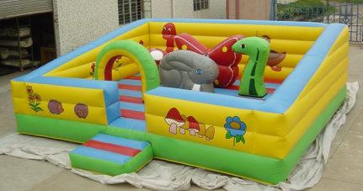
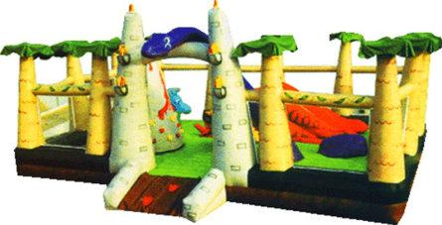
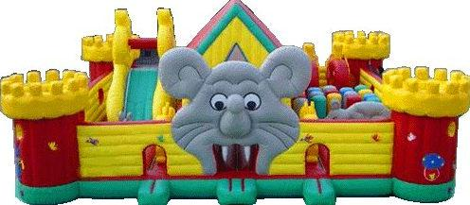

10/39

 |  | Material:0.45/0.55PVC | Tarpaulin
IC0060 |  | Size:diameter10m H4.5m |  | 280000
 |  | Blower:1pc，1500W/2pcs
 |  | Material:0.45/0.55PVC | Tarpaulin
IC0061 |  | Size:diameter6m H4.5m |  | 90000
 |  | Blower:1pc，1500W
 |  | Material:0.45/0.55PVC | Tarpaulin
IC0062 |  | Size:5mLx5mWx3mH |  | 63000
 |  | Blower:1pc，950W
 |  | Material:0.45/0.55PVC | Tarpaulin
IC0063 |  | Size:8mLx10mWx5.5mH |  | 210000
 |  | Blower:1pc，1100W/2pcs
 |  | Material:0.45/0.55PVC | Tarpaulin
IC0064 |  | Size:10mLx4mWx3.8mH |  | 105000
 |  | Blower:1pc，1500W
 |  | Material:0.45/0.55PVC | Tarpaulin
IC0065 |  | Size:6mLx10mWx4mH |  | 175000
 |  | Blower:1pc，1100W/2pcs

11/39

 |  | Material:0.45/0.55PVC | Tarpaulin
IC0066 |  | Size:5mLx5mWx3.8mH |  | 65000
 |  | Blower:1pc，1100W
 |  | Material:0.45/0.55PVC | Tarpaulin
IC0067 |  | Size:5mLx14mWx3.5mH |  | 175000
 |  | Blower:1pc，1100W/2pcs
 |  | Material:0.45/0.55PVC | Tarpaulin
IC0068 |  | Size:5mLx8mWx3.8mH |  | 105000
 |  | Blower:1pc，1500W
 |  | Material:0.45/0.55PVC | Tarpaulin
IC0069 |  | Size:4mLx16mWx3.8mH |  | 175000
 |  | Blower:1pc，1500W
 |  | Material:0.45/0.55PVC | Tarpaulin
IC0070 |  | Size:8mLx9mWx5mH |  | 180000
 |  | Blower:1pc，1100W/2pcs
 |  | Material:0.45/0.55PVC | Tarpaulin
IC0071 |  | Size:9mLx14mWx5mH |  | 315000
 |  | Blower:1pc，1500W/2pcs
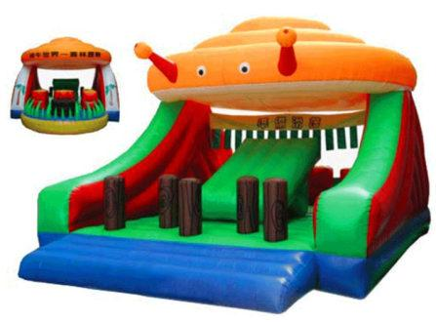
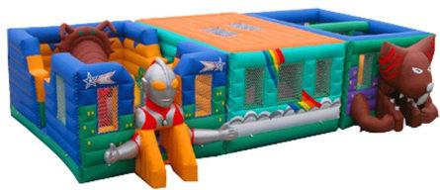

12/39

 |  | Material:0.45/0.55PVC | Tarpaulin
IC0072 |  | Size:9mLx16mWx5.5mH |  | 350000
 |  | Blower:1pc，1500W/2pcs
 |  | Material:0.45/0.55PVC | Tarpaulin
IC0073 |  | Size:9mLx16mWx5.5mH |  | 350000
 |  | Blower:1pc，1500W/2pcs
 |  | Material:0.45/0.55PVC | Tarpaulin
IC0074 |  | Size:8mLx8mWx8mH |  | 200000
 |  | Blower:1pc，1100W/2pcs
 |  | Material:0.45/0.55PVC | Tarpaulin
IC0075 |  | Size:7mLx10mWx7mH |  | 210000
 |  | Blower:1pc，1100W/2pcs
 |  | Material:0.45/0.55PVC | Tarpaulin
IC0076 |  | Size:7mLx10mWx5.5mH |  | 180000
 |  | Blower:1pc，1100W/2pcs
 |  | Material:0.45/0.55PVC | Tarpaulin
IC0077 |  | Size:8mLx12mWx8mH |  | 270000
 |  | Blower:1pc，1100W/2pcs
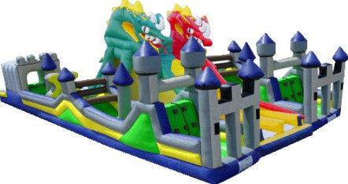
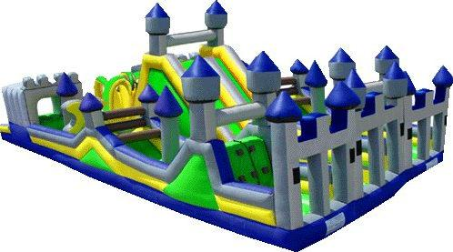
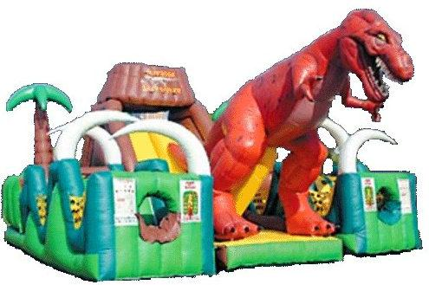
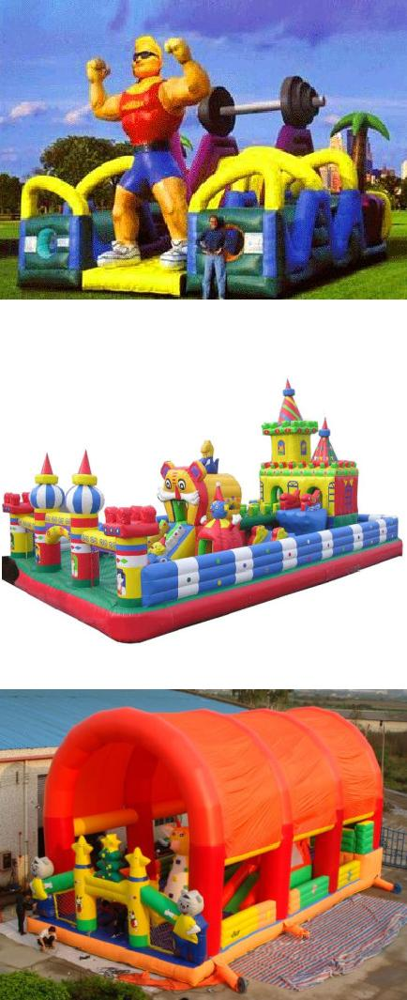

13/39

 |  | Material:0.45/0.55PVC | Tarpaulin
IC0078 |  | Size:7mLx10mWx5.5mH |  | 175000
 |  | Blower:1pc，1100W/2pcs
 |  | Material:0.45/0.55PVC | Tarpaulin
IC0079 |  | Size:5mLx20mWx5.5mH |  | 245000
 |  | Blower:1pc，1100W/2pcs
 |  | Material:0.45/0.55PVC | Tarpaulin
IC0080 |  | Size:10mLx12mWx6mH |  | 300000
 |  | Blower:1pc，1500W/2pcs
 |  | Material:0.45/0.55PVC | Tarpaulin
IC0081 |  | Size:10mLx15mWx6mH |  | 370000
 |  | Blower:1pc，1500W/2pcs
 |  | Material:0.45/0.55PVC | Tarpaulin
IC0082 |  | Size:5mLx10mWx2.8mH |  | 120000
 |  | Blower:1pc，1500W
 |  | Material:0.45/0.55PVC | Tarpaulin
IC0083 |  | Size:6mLx6mWx2.8mH |  | 87000
 |  | Blower:1pc，1100W
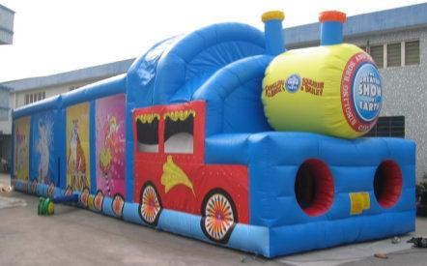
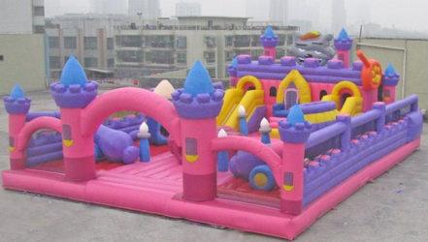
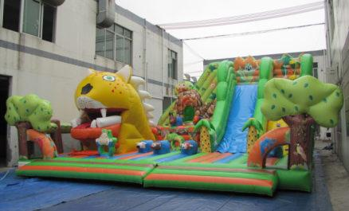
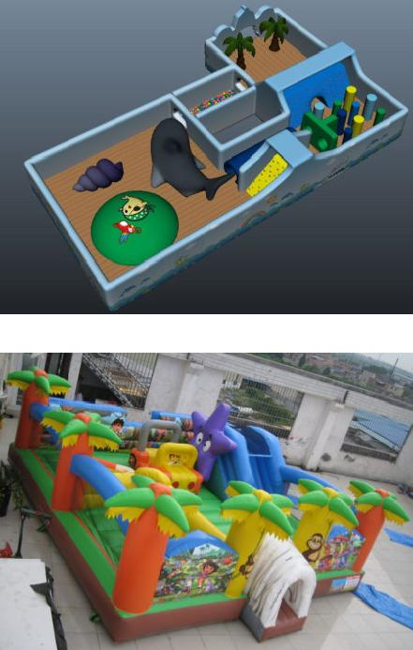

14/39

 |  | Material:0.45/0.55PVC | Tarpaulin
IC0084 |  | Size:4mLx4mWx2.4mH |  | 40000
 |  | Blower:1pc，950W
 |  | Material:0.45/0.55PVC | Tarpaulin
IC0085 |  | Size:4mLx7mWx2.8mH |  | 70000
 |  | Blower:1pc，1100W
 |  | Material:0.45/0.55PVC | Tarpaulin
IC0086 |  | Size:4mLx4mWx3.5mH |  | 45000
 |  | Blower:1pc，950W
 |  | Material:0.45/0.55PVC | Tarpaulin
IC0087 |  | Size:3.5mLx4mWx3.5mH |  | 38000
 |  | Blower:1pc，950W
 |  | Material:0.45/0.55PVC | Tarpaulin
IC0088 |  | Size:4.5mLx4.5mWx3.5mH |  | 56000
 |  | Blower:1pc，950W
 |  | Material:0.45/0.55PVC | Tarpaulin
IC0089 |  | Size:4mLx4.5mWx2.8mH |  | 50000
 |  | Blower:1pc，950W
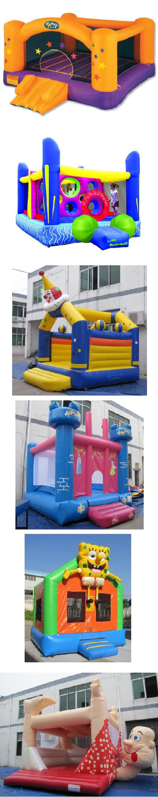

15/39

 |  | Material:0.45/0.55PVC | Tarpaulin
IC0090 |  | Size:5mLx8mWx2.8mH |  | 100000
 |  | Blower:1pc，1500W
 |  | Material:0.45/0.55PVC | Tarpaulin
IC0091 |  | Size:4.5mLx4.5mWx3.5mH |  | 55000
 |  | Blower:1pc，950W
 |  | Material:0.45/0.55PVC | Tarpaulin
IC0092 |  | Size:4.5mLx4.5mWx3.5mH |  | 55000
 |  | Blower:1pc，950W
 |  | Material:0.45/0.55PVC | Tarpaulin
IC0093 |  | Size:4.5mLx4.5mWx3.5mH |  | 56000
 |  | Blower:1pc，950W
 |  | Material:0.45/0.55PVC | Tarpaulin
IC0094 |  | Size:4mLx5mWx3.2mH |  | 53000
 |  | Blower:1pc，950W
 |  | Material:0.45/0.55PVC | Tarpaulin
IC0095 |  | Size:4mLx4mWx3.2mH |  | 47000
 |  | Blower:1pc，950W
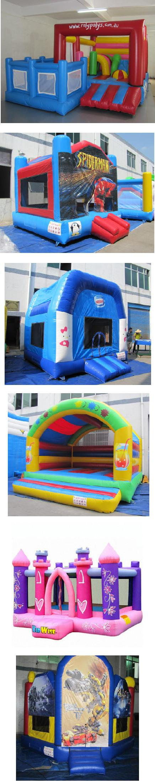

16/39

 |  | Material:0.45/0.55PVC | Tarpaulin
IC0096 |  | Size:4mLx4mWx3.5mH |  | 47000
 |  | Blower:1pc，950W
 |  | Material:0.45/0.55PVC | Tarpaulin
IC0097 |  | Size:3mLx3mWx3mH |  | 28000
 |  | Blower:1pc，950W
 |  | Material:0.45/0.55PVC | Tarpaulin
IC0098 |  | Size:3.5mLx3.5mWx3.5mH |  | 35000
 |  | Blower:1pc，950W
 |  | Material:0.45/0.55PVC | Tarpaulin
IC0099 |  | Size:3mLx5mWx2.5mH |  | 42000
 |  | Blower:1pc，950W
 |  | Material:0.45/0.55PVC | Tarpaulin
IC0100 |  | Size:4mLx4mWx3.5mH |  | 45000
 |  | Blower:1pc，950W
 |  | Material:0.45/0.55PVC | Tarpaulin
IC0101 |  | Size:4mLx4mWx3.8mH |  | 42000
 |  | Blower:1pc，950W
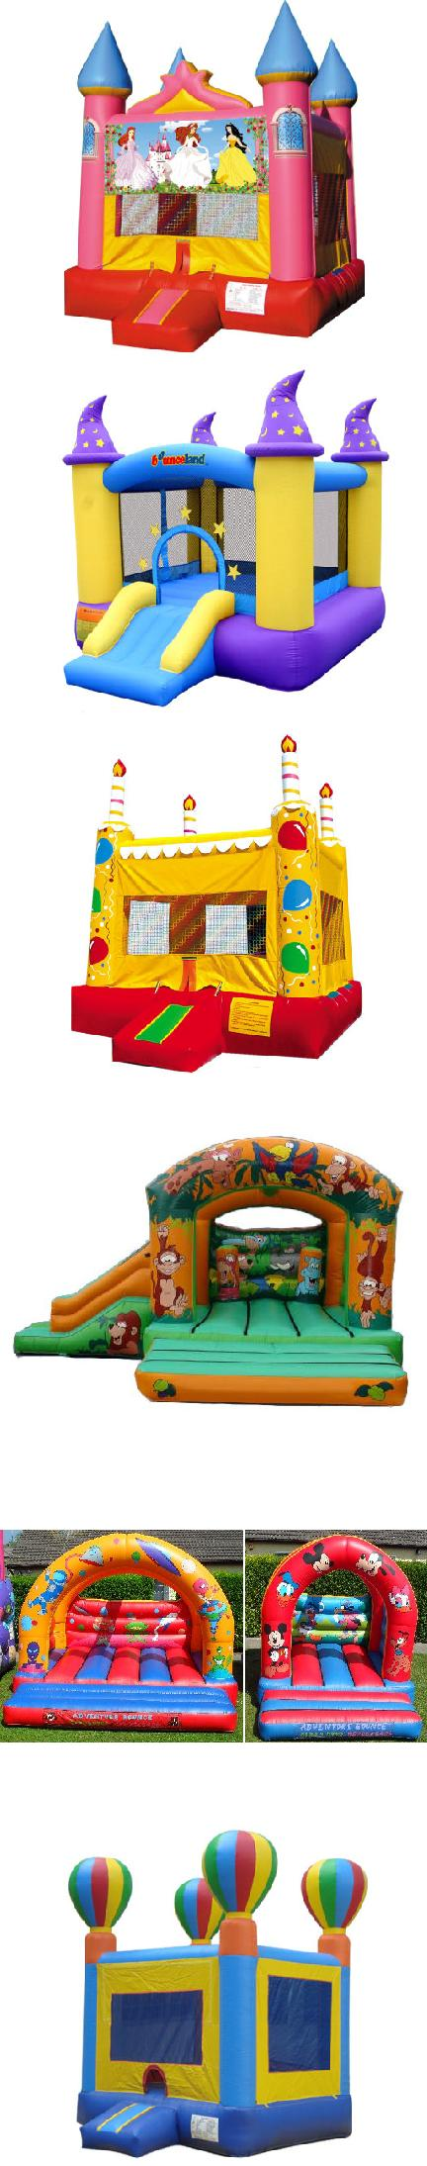

17/39

 |  | Material:0.45/0.55PVC | Tarpaulin
IC0102 |  | Size:4mLx4mWx3.2mH |  | 42000
 |  | Blower:1pc，950W
 |  | Material:0.45/0.55PVC | Tarpaulin
IC0103 |  | Size:4mLx4mWx3.5mH |  | 42000
 |  | Blower:1pc，950W
 |  | Material:0.45/0.55PVC | Tarpaulin
IC0104 |  | Size:4mLx4mWx3.5mH |  | 42000
 |  | Blower:1pc，950W
 |  | Material:0.45/0.55PVC | Tarpaulin
IC0105 |  | Size:4.5mLx4.5mWx3.5mH |  | 52000
 |  | Blower:1pc，950W
 |  | Material:0.45/0.55PVC | Tarpaulin
IC0106 |  | Size:4.5mLx4.5mWx3.5mH |  | 53000
 |  | Blower:1pc，950W
 |  | Material:0.45/0.55PVC | Tarpaulin
IC0107 |  | Size:4.5mLx4.5mWx3.5mH |  | 53000
 |  | Blower:1pc，950W
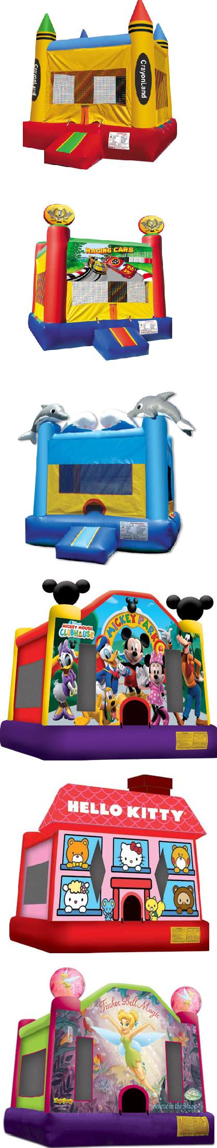

18/39

 |  | Material:0.45/0.55PVC | Tarpaulin
IC0108 |  | Size:3.5mLx3.5mWx4mH |  | 35000
 |  | Blower:1pc，950W
 |  | Material:0.45/0.55PVC | Tarpaulin
IC0109 |  | Size:4.5mLx4.5mWx3.5mH |  | 53000
 |  | Blower:1pc，950W
 |  | Material:0.45/0.55PVC | Tarpaulin
IC0110 |  | Size:4.5mLx4.5mWx3.5mH |  | 53000
 |  | Blower:1pc，950W
 |  | Material:0.45/0.55PVC | Tarpaulin
IC0111 |  | Size:4.5mLx4.5mWx3.5mH |  | 53000
 |  | Blower:1pc，950W
 |  | Material:0.45/0.55PVC | Tarpaulin
IC0112 |  | Size:4.5mLx4.5mWx3.5mH |  | 53000
 |  | Blower:1pc，950W
 |  | Material:0.45/0.55PVC | Tarpaulin
IC0113 |  | Size:4.5mLx4.5mWx3.5mH |  | 53000
 |  | Blower:1pc，950W

19/39

 |  | Material:0.45/0.55PVC | Tarpaulin
IC0114 |  | Size:4.5mLx4.5mWx3.5mH |  | 53000
 |  | Blower:1pc，950W
 |  | Material:0.45/0.55PVC | Tarpaulin
IC0115 |  | Size:6mLx6mW |  | 70000
 |  | Blower:1pc，950W
 |  | Material:0.45/0.55PVC | Tarpaulin
IC0116 |  | Size:4mLx4mWx3.5mH |  | 42000
 |  | Blower:1pc，950W
 |  | Material:0.45/0.55PVC | Tarpaulin
IC0117 |  | Size:3.5mLx3.5mWx3.5mH |  | 35000
 |  | Blower:1pc，950W
 |  | Material:0.45/0.55PVC | Tarpaulin
IC0118 |  | Size:3.5mLx4.5mWx3mH |  | 38000
 |  | Blower:1pc，950W
 |  | Material:0.45/0.55PVC | Tarpaulin
IC0119 |  | Size:4.5mLx5mWx3mH |  | 63000
 |  | Blower:1pc，950W
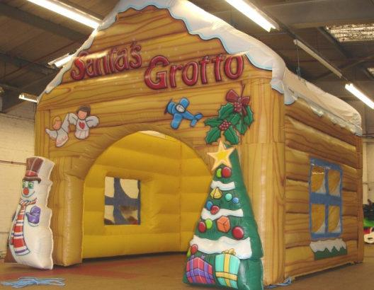
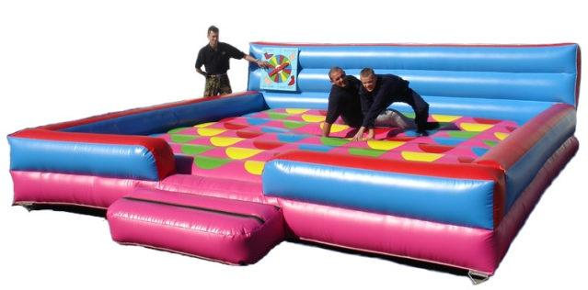
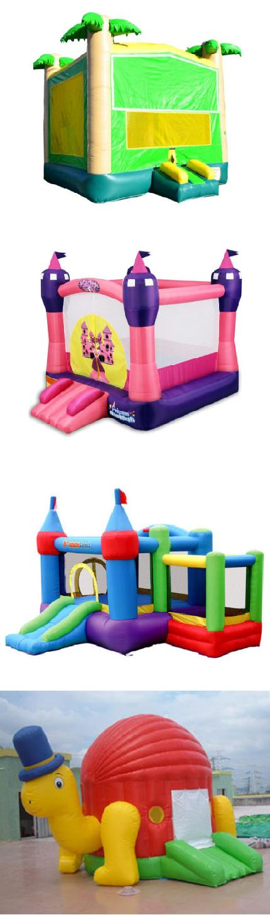

20/39

 |  | Material:0.45/0.55PVC | Tarpaulin
IC0120 |  | Size:4mLx6mWx3.5mH |  | 63000
 |  | Blower:1pc，950W
 |  | Material:0.45/0.55PVC | Tarpaulin
IC0121 |  | Size:4mLx6mWx3.5mH |  | 63000
 |  | Blower:1pc，950W
 |  | Material:0.45/0.55PVC | Tarpaulin
IC0122 |  | Size:5mLx5mWx4mH |  | 67000
 |  | Blower:1pc，950W
 |  | Material:0.45/0.55PVC | Tarpaulin
IC0123 |  | Size:5mLx5mWx4mH |  | 67000
 |  | Blower:1pc，950W
 |  | Material:0.45/0.55PVC | Tarpaulin
IC0124 |  | Size:5mLx5mWx5mH |  | 67000
 |  | Blower:1pc，950W
 |  | Material:0.45/0.55PVC | Tarpaulin
IC0125 |  | Size:4.5mLx4.5mWx3.8mH |  | 56000
 |  | Blower:1pc，950W
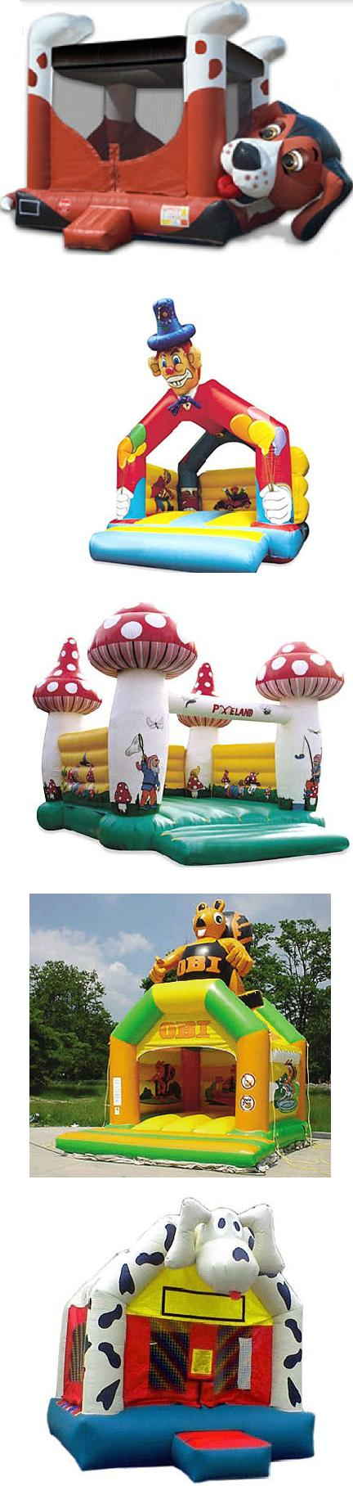

21/39

 |  | Material:0.45/0.55PVC | Tarpaulin
IC0126 |  | Size:5mLx5mWx4mH |  | 67000
 |  | Blower:1pc，950W
 |  | Material:0.45/0.55PVC | Tarpaulin
IC0127 |  | Size:5mLx5mWx3.8mH |  | 63000
 |  | Blower:1pc，950W
 |  | Material:0.45/0.55PVC | Tarpaulin
IC0128 |  | Size:5mLx5mWx3.8mH |  | 63000
 |  | Blower:1pc，950W
 |  | Material:0.45/0.55PVC | Tarpaulin
IC0129 |  | Size:5mLx6mWx3.5mH |  | 74000
 |  | Blower:1pc，950W
 |  | Material:0.45/0.55PVC | Tarpaulin
IC0130 |  | Size:4.5mLx4.5mWx3.8mH |  | 56000
 |  | Blower:1pc，950W
 |  | Material:0.45/0.55PVC | Tarpaulin
IC0131 |  | Size:4.5mLx4.5mWx3.8mH |  | 56000
 |  | Blower:1pc，950W
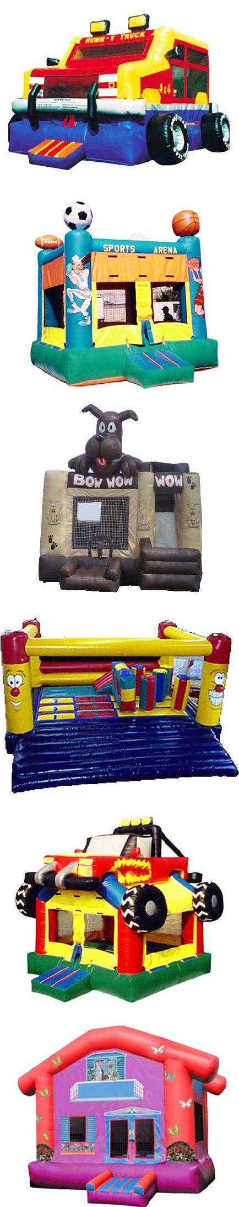

22/39

 |  | Material:0.45/0.55PVC | Tarpaulin
IC0132 |  | Size:4.5mLx4.5mWx3.8mH |  | 56000
 |  | Blower:1pc，950W
 |  | Material:0.45/0.55PVC | Tarpaulin
IC0133 |  | Size:3.5mLx3.5mWx3.5mH |  | 35000
 |  | Blower:1pc，950W
 |  | Material:0.45/0.55PVC | Tarpaulin
IC0134 |  | Size:5mLx5mWx3.5mH |  | 67000
 |  | Blower:1pc，950W
 |  | Material:0.45/0.55PVC | Tarpaulin
IC0135 |  | Size:5mLx6mWx3.8mH |  | 79000
 |  | Blower:1pc，950W
 |  | Material:0.45/0.55PVC | Tarpaulin
IC0136 |  | Size:5mLx5mWx3.8mH |  | 67000
 |  | Blower:1pc，950W
 |  | Material:0.45/0.55PVC | Tarpaulin
IC0137 |  | Size:5mLx5mWx3.8mH |  | 73000
 |  | Blower:1pc，950W
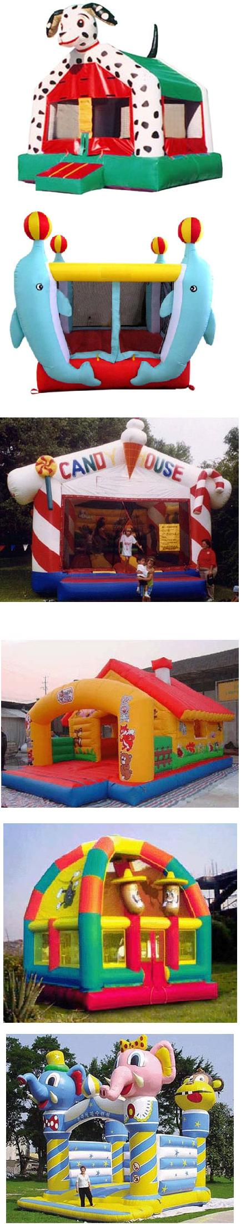

23/3

 |  | Material:0.45/0.55PVC | Tarpaulin
IC0138 |  | Size:5mLx5mWx3.8mH |  | 73000
 |  | Blower:1pc，950W
 |  | Material:0.45/0.55PVC | Tarpaulin
IC0139 |  | Size:5mLx5mWx3.8mH |  | 67000
 |  | Blower:1pc，950W
 |  | Material:0.45/0.55PVC | Tarpaulin
IC0140 |  | Size:6mLx5mWx4mH |  | 88000
 |  | Blower:1pc，1100W
 |  | Material:0.45/0.55PVC | Tarpaulin
IP0001 |  | Size:4.5mLx4.5mWx4mH |  | 47000
 |  | Blower:1pc，950W
 |  | Material:0.6PVC Tarpaulin
IP0002 |  | Size:5mLx2.5mWx2.5mH |  | 32000
 |  | Blower:1pc，680W
 |  | Material:0.6PVC Tarpaulin
IP0003 |  | Size:5.5mLx20mWx1.8mH |  | 204000
 |  | Blower:1pc，680W
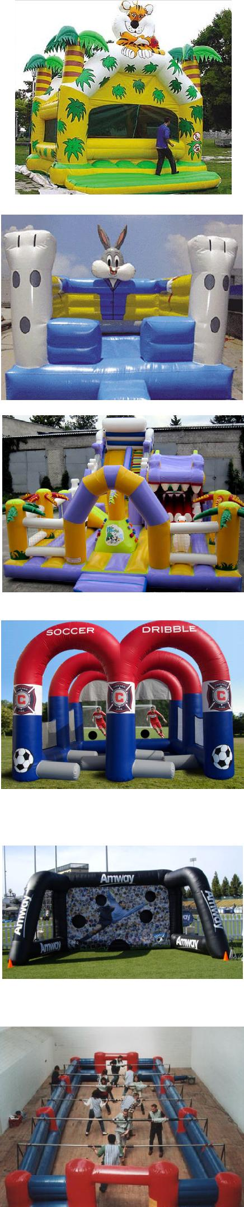

24/39

 |  | Material:0.6PVC Tarpaulin
IP0004 |  | Size:5.5mLx20mWx1.8mH | 204000
 |  | Blower:1pc，680W
 |  | Material:0.6PVC Tarpaulin
IP0005 |  | Size:6mLx22mWx2mH | 186000
 |  | Blower:1pc，680W
 |  | Material:0.6PVC Tarpaulin
IP0006 |  | Size:6mLx18mWx2mH | 162000
 |  | Blower:1pc，680W
 |  | Material:0.6PVC Tarpaulin
IP0007 |  | Size:5mLx20mWx2mH | 144000
 |  | Blower:1pc，680W
 |  | Material:0.6PVC Tarpaulin
IP0008 |  | Size:6mLx10mWx2.8mH | 85000
 |  | Blower:1pc，950W
 |  | Material:0.45/0.55PVC Tarpaulin
IP0009 |  | Size:10mLx20mWx3.5mH | 176000
 |  | Blower:1pc，1500W
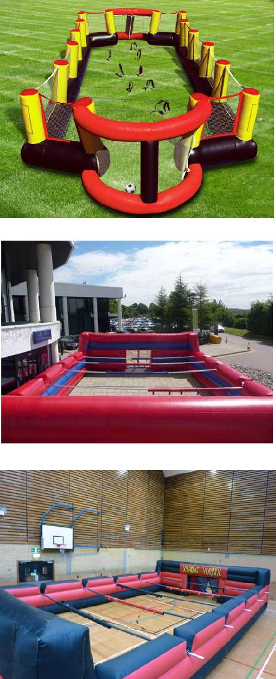
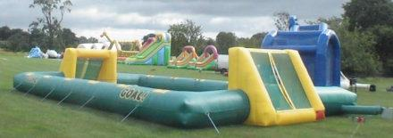

25/39

 |  | Material:0.6PVC Tarpaulin
IP0010 |  | Size:8mLx20mWx3mH |  | 388000
 |  | Blower:1pc，680W
 |  | Material:0.6PVC Tarpaulin
IP0011 |  | Size:5mLx2.5mWx2.5mH |  | 23000
 |  | Blower:1pc，680W
 |  | Material:0.6PVC Tarpaulin
IP0012 |  | Size:8mLx10mWx2.5mH |  | 84000
 |  | Blower:1pc，680W
 |  | Material:0.45/0.55PVC | Tarpaulin
IP0013 |  | Size:4mLx6mWx5mH |  | 59000
 |  | Blower:1pc，950W
 |  | Material:0.45/0.55PVC | Tarpaulin
IP0014 |  | Size:5mLx5mWx5mH |  | 67000
 |  | Blower:1pc，950W
 |  | Material:0.45/0.55PVC | Tarpaulin
IP0015 |  | Size:3mLx3.5mWx3.5mH |  | 33000
 |  | Blower:1pc，680W
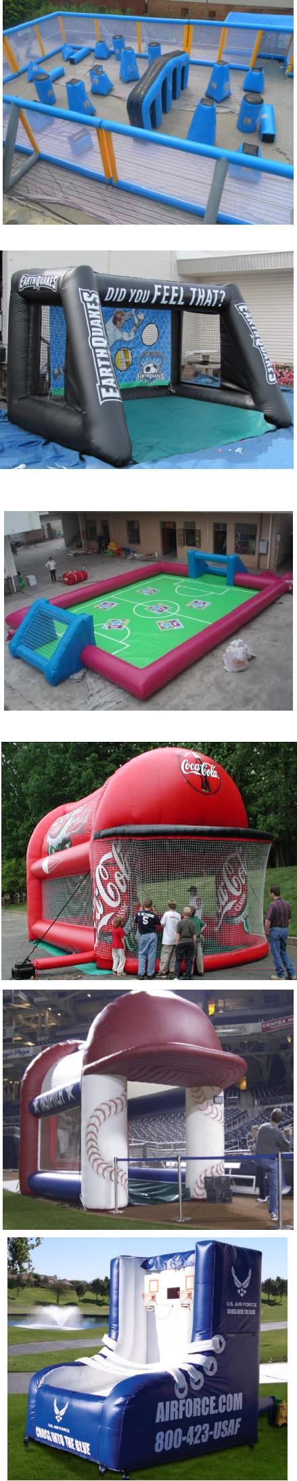

26/39

 |  | Material:0.45/0.55PVC | Tarpaulin
IP0016 |  | Size:3mLx3.5mWx3.5mH |  | 33000
 |  | Blower:1pc，680W
 |  | Material:0.45/0.55PVC | Tarpaulin
IP0017 |  | Size:3mLx3.5mWx3.5mH |  | 31500
 |  | Blower:1pc，680W
 |  | Material:0.45/0.55PVC | Tarpaulin
IP0018 |  | Size:3mLx3.5mWx3.5mH |  | 31500
 |  | Blower:1pc，680W
 |  | Material:0.45/0.55PVC | Tarpaulin
IP0019 |  | Size:3mLx4mWx4mH |  | 34000
 |  | Blower:1pc，680W
 |  | Material:0.45/0.55PVC | Tarpaulin
IP0020 |  | Size:3.5mLx3.5mWx3.5mH |  | 26000
 |  | Blower:1pc，680W
 |  | Material:0.45/0.55PVC | Tarpaulin
IP0021 |  | Size:4.5mLx4.5mWx1.8mH |  | 46000
 |  | Blower:1pc，950W
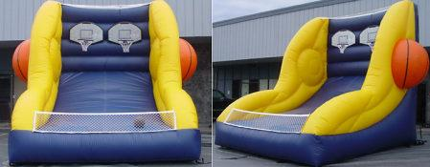
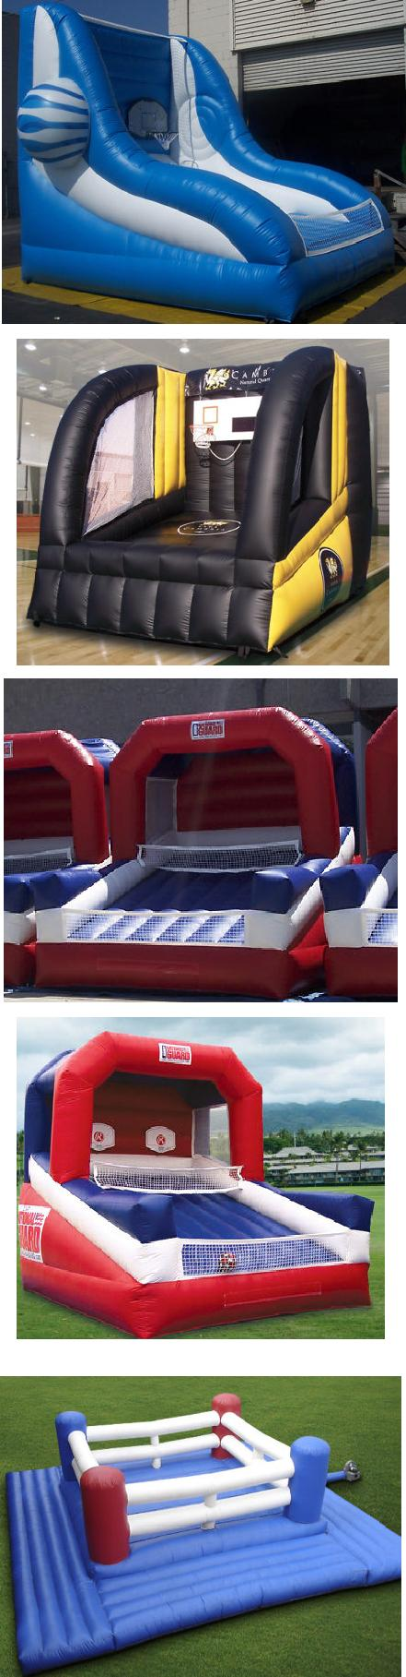

27/39

 |  | Material:0.6PVC Tarpaulin
IP0022 |  | Size:4.5mLx8mWx0.5mH |  | 55000
 |  | Blower:1pc，680W
 |  | Inflatable balance game
IP0023 |  | Material:0.45/0.55PVC | Tarpaulin | 72000
 |  | Size:5mLx5mWx2.5mH
 |  | Blower:1pc，950W
 |  | Material:0.45/0.55PVC | Tarpaulin
IP0024 |  | Size:3.5mLx5.5mWx3.5mH |  | 48000
 |  | Blower:1pc，950W
 |  | Material:0.45/0.55PVC | Tarpaulin
IP0025 |  | Size:3mLx4mWx3mH |  | 37000
 |  | Blower:1pc，680W
 |  | Material:0.45/0.55PVC | Tarpaulin
IP0026 |  | Size:4mLx4mWx3.5mH |  | 39000
 |  | Blower:1pc，950W
 |  | Material:0.45/0.55PVC | Tarpaulin
IP0027 |  | Size:3mLx5mWx3.5mH |  | 43500
 |  | Blower:1pc，950W
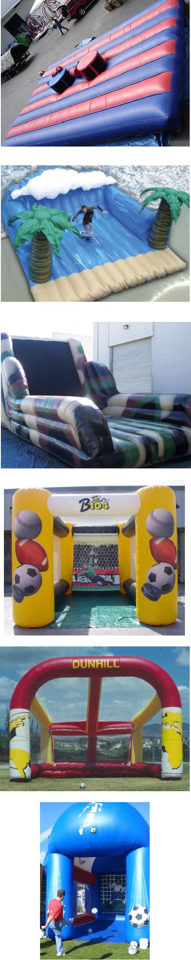

28/39

 |  | Material:1.0PVC | Tarpaulin
WB0001 |  | Size:2.3mLx2.5mW |  | 34000
 |  | Dia:1.8m/2/3m
 |  | Blower:1pc，680W
 |  | Material:1.0PVC | Tarpaulin
WB0002 |  | Size:height 1.3mx0.8mx0.8m |  | 18000
 |  | Blower:1pc，680W
 |  | Material:1.0PVC | Tarpaulin
WB0003 |  | Size: diameter 2.3m |  | 26000
 |  | Blower:1pc，680W
 |  | Material:1.0PVC | Tarpaulin
WB0004 |  | Size:height1.3mx0.8m |  | 18000
 |  | Blower:1pc，680W
 |  | Material:0.8PVC | Tarpaulin
WB0005 |  | Size:diameter 1.8m |  | 15000
 |  | Blower:1pc，680W
 |  | Material:0.6PVC | Tarpaulin
WB0006 |  | Size:3mLx5mWx0.6mH |  | 43500
 |  | Blower:1pc，680W
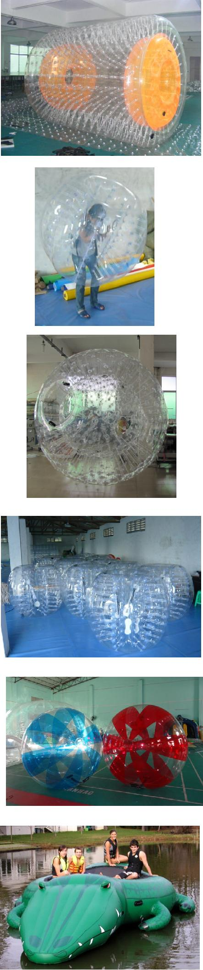

29/39

 |  | Material:0.6PVC | Tarpaulin
WB0007 |  | Size:3mLx7mWx2.2mH |  | 46000
 |  | Blower:1pc，680W
 |  | Material:0.6PVC | Tarpaulin
WB0008 |  | Size:3mLx7mWx2.2mH |  | 46000
 |  | Blower:1pc，680W
 |  | Material:0.6PVC | Tarpaulin
WB0009 |  | Size:diameter 2.8m 2.8mH |  | 34000
 |  | Blower:1pc，680W
 |  | Material:0.6PVC | Tarpaulin
WB0010 |  | Size:3.5mLx7mWx2.7mH |  | 79000
 |  | Blower:1pc，680W
 |  | Material:0.6PVC | Tarpaulin
WB0011 |  | Size:3.5mLx7mWx2.7mH |  | 65000
 |  | Blower:1pc，680W
 |  | Material:0.9PVC | Tarpaulin
WB0012 |  | Size:3mLx0.6mWx0.6mH |  | 23000
 |  | Blower:1pc，680W
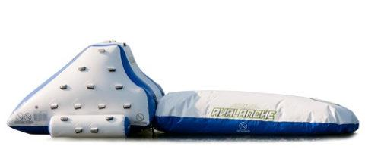

30/39

 |  | Material:0.6PVC Tarpaulin
WB0013 |  | Size:diameter 3m 3mH | 34000
 |  | Blower:1pc，680W
 |  | Material:0.6PVC Tarpaulin
WB0014 |  | Size:1.2mLx4mWx0.8mH | 20000
 |  | Blower:1pc，680W
 |  | Material:0.6PVC Tarpaulin
WB0015 |  | Size:2mLx3.5mWx1.8mH | 18500
 |  | Blower:1pc，680W
 |  | Material:0.6PVC Tarpaulin
WB0016 |  | Size:2mLx1mWx2mH | 15000
 |  | Blower:1pc，680W
 |  | Material:0.55PVC Tarpaulin
WB0017 |  | Size:3mLx12mWx2.8mH | 60000
 |  | Blower:1pc，950W
 |  | Material:0.6PVC Tarpaulin
WB0018 |  | Size:5mLx5mWx2.5mH | 41000
 |  | Blower:1pc，680W
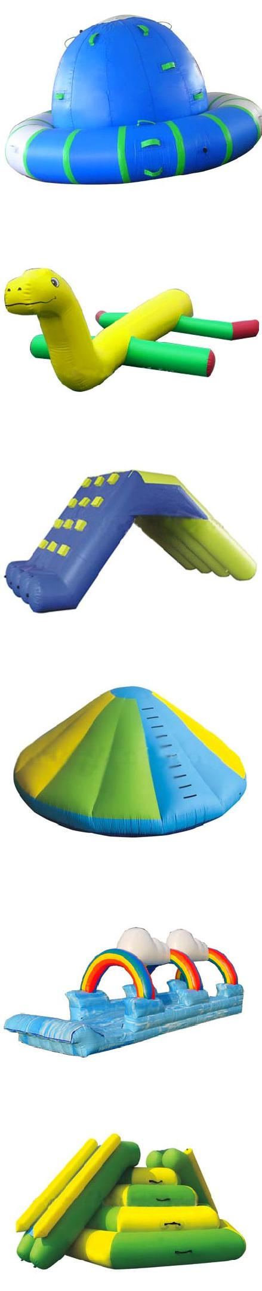

31/39

 |  | Material:0.9PVC Tarpaulin
WB0019 |  | Size:3mLx3mWx0.8mH | 29000
 |  | Blower:1pc，680W
 |  | Material:0.6PVC Tarpaulin
WB0020 |  | Size:2mLx3.5mWx0.6mH | 22000
 |  | Blower:1pc，680W
 |  | Material:0.55PVC Tarpaulin
WB0021 |  | Size:2.5mLx10mWx2.2mH | 39000
 |  | Blower:1pc，1100W
 |  | Material:0.9PVC Tarpaulin
WB0023 |  | Size:2.3mLx2.8mWx2.3mH | 41000
 |  | Blower:1pc，680W
 |  | Material:0.6PVC Tarpaulin
WB0024 |  | Size:4mLx12mWx3mH | 93000
 |  | Blower:1pc，680W
 |  | Material:0.6PVC Tarpaulin
WB0025 |  | Size:3mLx3mWx3mH | 20000
 |  | Blower:1pc，680W
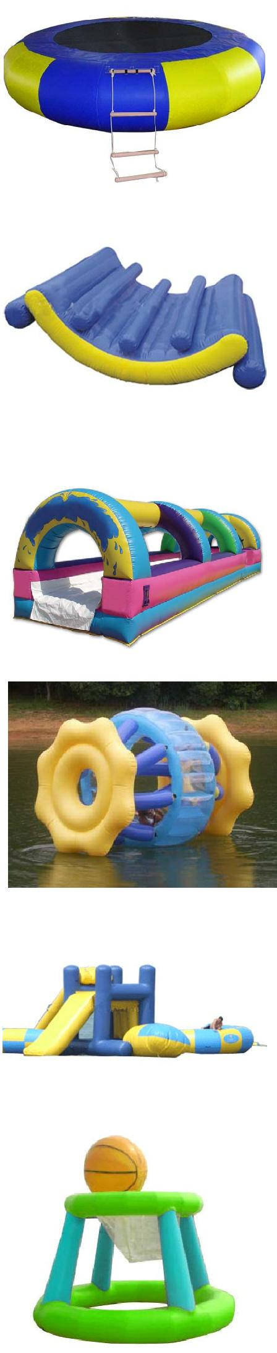

32/39

 |  | Material:0.9PVC | Tarpaulin
WB0026 |  | Size:1.5mLx3.5mWx0.6mH |  | 18500
 |  | Blower:1pc，680W
 |  | Material:0.6PVC | Tarpaulin
WB0027 |  | Size:1.5mLx4mW x2.0mH |  | 24500
 |  | Blower:1pc，680W
 |  | Material:0.9PVC | Tarpaulin
WB0028 |  | Size:2.5mLx10mWx1.8mH |  | 32000
 |  | Blower:1pc，680W
 |  | Material:0.9PVC | Tarpaulin
WB0029 |  | Size:2.5mLx4mW x2mH |  | 23000
 |  | Blower:1pc，680W
 |  | Caterpillar
WB0030 |  | Material:0.9PVC | Tarpaulin | 18500
 |  | Size:0.8mLx6mW x0.8mH
 |  | Blower:1pc，680W
 |  | Material:0.9PVC | Tarpaulin
WB0031 |  | Size:2.3mLx2.5mW x2.3mH |  | 47000
 |  | Blower:1pc，680W
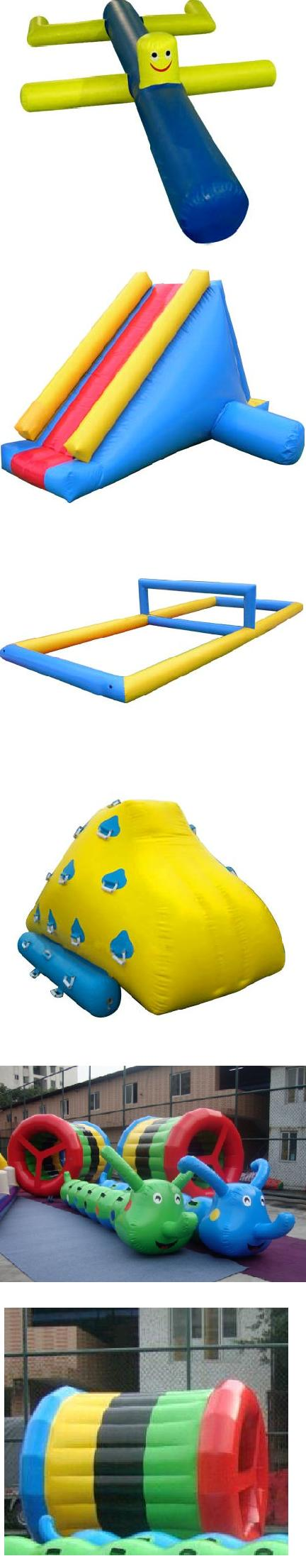

33/39

 |  | Material:0.6/0.9PVC Tarpaulin
WB0032 |  | Size:1000sqm water |  | 2380700
 |  | inflatablesBlower:1pc，680W
 |  | Material:0.45/0.55PVC | Tarpaulin
IW0001 |  | Size:6mLx4mWx3.5mH |  | 54000
 |  | Blower:1pc，950W
 |  | Material:0.45/0.55PVC | Tarpaulin
IW0002 |  | Size:4mLx6mWx3.5mH |  | 39000
 |  | Blower:1pc，680W
 |  | Material:0.45/0.55PVC | Tarpaulin
IW0003 |  | Size:4mLx6mWx3.5mH |  | 53500
 |  | Blower:1pc，950W
 |  | Material:0.45/0.55PVC | Tarpaulin
IW0004 |  | Size:3.5mLx4mWx3.5mH |  | 34000
 |  | Blower:1pc，680W
 |  | Material:0.45/0.55PVC | Tarpaulin
IW0005 |  | Size:3mLx4.5mWx3mH |  | 36500
 |  | Blower:1pc，950W
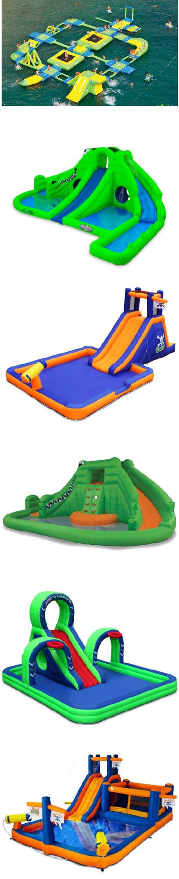

34/39

 |  | Material:0.45/0.55PVC | Tarpaulin
IW0006 |  | Size:4.5mLx4.5mWx2.4mH |  | 56000
 |  | Blower:1pc，950W
 |  | Material:0.45/0.55PVC | Tarpaulin
IW0007 |  | Size:3mLx4.5mWx3.5mH |  | 40000
 |  | Blower:1pc，680W
 |  | Material:0.45/0.55PVC | Tarpaulin
IW0008 |  | Size:5mLx5mWx3.5mH |  | 67000
 |  | Blower:1pc，950W
 |  | Material:0.45/0.55PVC | Tarpaulin
IW0009 |  | Size:5mLx5mWx3.8mH |  | 67000
 |  | Blower:1pc，950W
 |  | Material:0.45/0.55PVC | Tarpaulin
IW0010 |  | Size:4mLx4mWx3.5mH |  | 46000
 |  | Blower:1pc，680W
 |  | Material:0.45/0.55PVC | Tarpaulin
IW0011 |  | Size:3.5mLx13mWx4mH |  | 121500
 |  | Blower:1pc，1100W
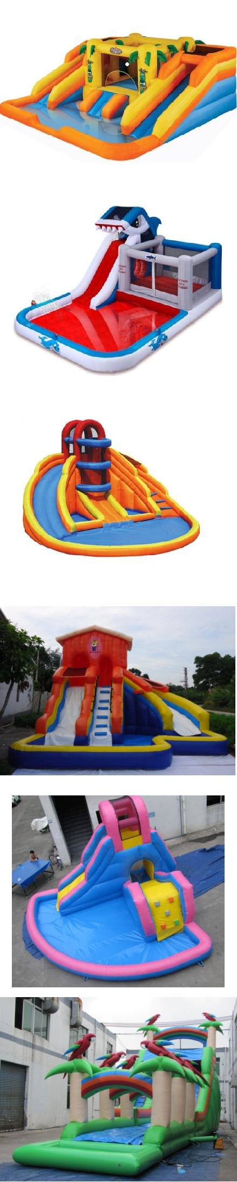

35

 |  | Material:0.45/0.55PVC | Tarpaulin
IW0012 |  | Size:6mLx9mWx7mH |  | 116000
 |  | Blower:1pc，1500W
 |  | Material:0.45/0.55PVC | Tarpaulin
IW0013 |  | Size:3.5mLx10mWx5mH |  | 99000
 |  | Blower:1pc，1100W
 |  | Material:0.45/0.55PVC | Tarpaulin
IW0014 |  | Size:4.5mLx12mWx6mH |  | 150500
 |  | Blower:1pc，1500W
 |  | Material:0.45/0.55PVC | Tarpaulin
IW0015 |  | Size:6mLx45mWx7mH |  | 679000
 |  | Blower:1pc，1500W/4pcs
 |  | Material:0.55/0.6PVC Tarpaulin
IW0016 |  | Size:350sqm water pool |  | 587000
 |  | Blower:1pc，1500W/1pc
 |  | 680W/1pc
 |  | Material:0.45/0.55PVC | Tarpaulin
IW0017 |  | Size:5mLx45mWx7mH |  | 572000
 |  | Blower:1pc，1500W/4pcs
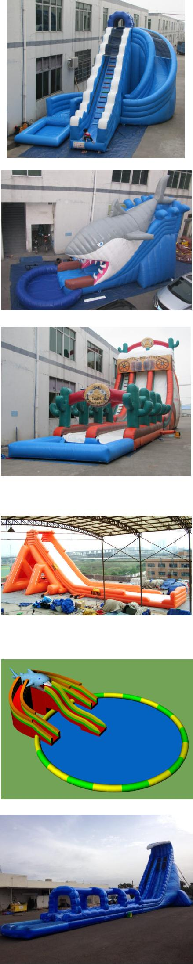

36/3

 |  | Material:0.45/0.55PVC | Tarpaulin
IW0018 |  | Size:5mLx15mWx7mH |  | 197000
 |  | Blower:1pc，1500W/2pcs
 |  | Material:0.45/0.55PVC | Tarpaulin
IW0019 |  | Size:5.5mLx9mWx7mH |  | 136500
 |  | Blower:1pc，1500W/2pcs
 |  | Material:0.45/0.55PVC | Tarpaulin
IW0020 |  | Size:5mLx9mWx6mH |  | 126000
 |  | Blower:1pc，1500W/2pcs
 |  | Material:0.45/0.55PVC | Tarpaulin
IW0021 |  | Size:4mLx9mWx6mH |  | 85500
 |  | Blower:1pc，1500W
 |  | Material:0.45/0.55PVC | Tarpaulin
IW0022 |  | Size:5mLx9mWx6mH |  | 126000
 |  | Blower:1pc，1500W/2pcs
 |  | Material:0.45/0.55PVC | Tarpaulin
IW0023 |  | Size:3mLx7mWx3.5mH |  | 55000
 |  | Blower:1pc，1100W
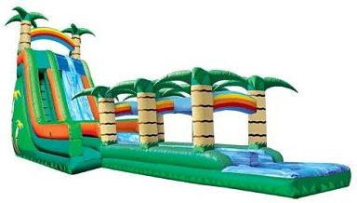
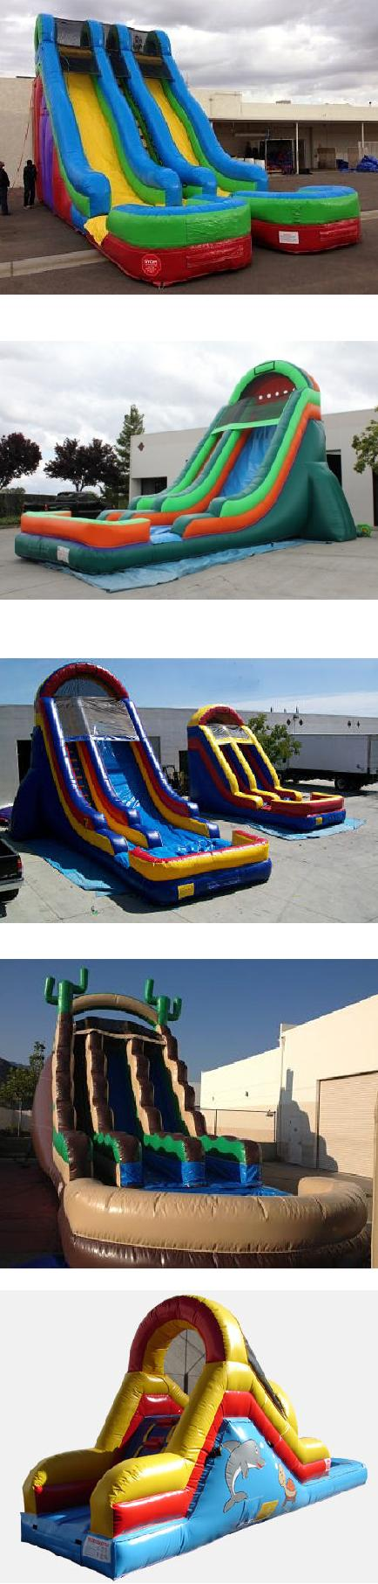

37/3

 |  | Material:0.45/0.55PVC Tarpaulin
IW0024 |  | Size:3mLx11mWx3.5mH | 86000
 |  | Blower:1pc，1100W
 |  | Material:0.45/0.55PVC Tarpaulin
IW0025 |  | Size:2.8mLx14mWx2.5mH | 100500
 |  | Blower:1pc，1100W
 |  | Material:0.45/0.55PVC Tarpaulin
IW0026 |  | Size:2.5mLx12mWx2.4mH | 65000
 |  | Blower:1pc，1100W
 |  | Material:0.55/0.6PVC Tarpaulin
IW0028 |  | Size:400sqm water pool | 1174000
 |  | Blower:1pc，1500W/2pcs
 |  | 680W/2pcs
 |  | Material:0.55PVC Tarpaulin
IW0029 |  | Size:5mLx12mWx7mH | 161500
 |  | Blower:1pc，1500W/2pcs
 |  | Material:0.55/0.6PVC Tarpaulin
IW0030 |  | Size:4.5mLx9mWx7mH | 106000
 |  | Blower:1pc，1500W
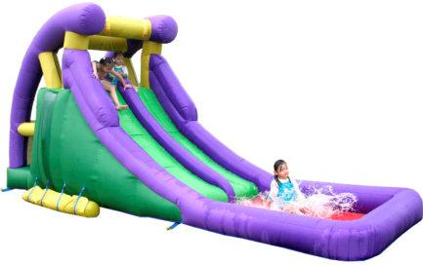
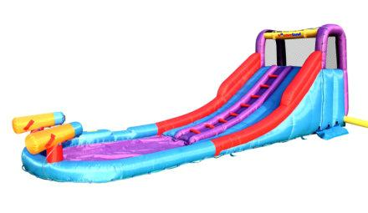
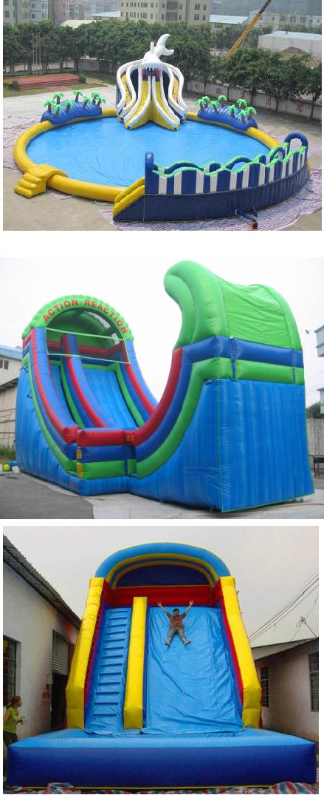

38/39

 |  | Material:0.45/0.55PVC | Tarpaulin
IW0031 |  | Size:4mLx18mWx7mH |  | 190000
 |  | Blower:1pc，1500W/2pcs
 |  | Material:0.45/0.55PVC | Tarpaulin
IW0032 |  | Size:6mLx9mWx6mH |  | 175000
 |  | Blower:1pc，1100W/2pcs
 |  | Material:0.45/0.55PVC | Tarpaulin
IW0033 |  | Size:4mLx10mWx5mH |  | 105000
 |  | Blower:1pc，1500W
 |  | Material:0.45/0.55PVC | Tarpaulin
 |  | Size:5mLx7mWx5mH
IS0001 |  | Blower:1pc, 1500W |  | 102000
 |  | Weight: 120KGS
 |  | Package size: 80*80*120cm
PS:the price includes blower with CE or UL or CUL certificate.
Payment Term: 30% deposit, 70% balance before delivery
Lead Time: 15 days after receiving the deposit
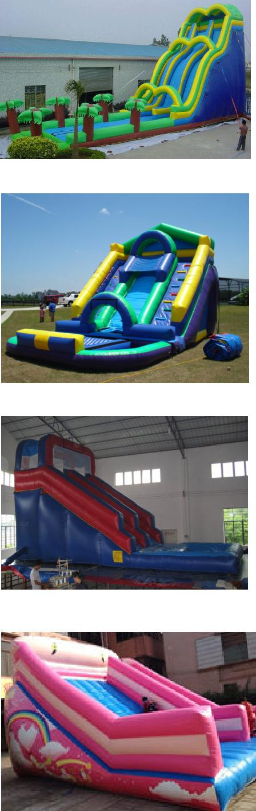

39/39

